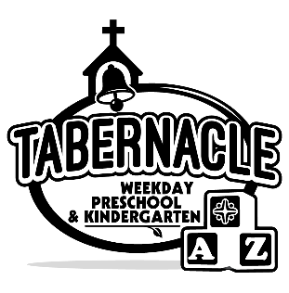

Tabernacle Weekday Preschool
2023-2024 Registration Year Registration
31 Douglas Street
Cartersville, GA 30120
770-382-8894
770-382-6988 (Fax)

Child’s Name___________________________________________ Date Of Birth________________________

Circle One: Male / Female T-Shirt Size: XS S M

___Toddlers (15-24mos.) Tuesday, Thursday $195/month
___ 2 year old Monday, Wednesday, Friday $225/month
___ 2 year old Monday – Friday $255/month
___ 3 year old Monday, Wednesday, Friday $225/month
___ 3 year old Monday – Friday $255/month
___ Pre-K Monday, Wednesday, Friday $225/month
___ Pre-K Monday – Friday $255/month
___ Kindergarten Monday – Friday $285/month
Children must have attained class age on or before September 1st of the school year.
* Registration/Activity Fee of $175 for Toddlers, Twos, Threes, Pre-K, and Kindergarten (non-refundable)
*Book Fee for Pre-K is $90 or Kindergarten is $110 (non-refundable)

Person responsible
for monthly tuition ________________________________________ Home Phone_______________________

Relationship to child ____________________________ Cell Phone ________________________

Mailing Address_________________________________________________________________________

City & Zip ____________________________________ Email Address _____________________________

Mother’s Name ____________________________________

Mailing Address (if different from address listed above)

_____________________________________________________City & Zip ____________________________

Mother’s Home Phone____________________ Cell Phone__________________________

Mother’s Employer/Occupation______________________________ Phone __________________

Father’s Name________________________________________

Father’s Home Phone____________________________Cell Phone________________________________

Father’s Employer/Occupation______________________________ Phone _________________________

Child Resides With: ( ) Both Natural Parents ( )One Natural Parent
( ) Natural Parent/Step ( )Legal Guardian
( ) Foster Parents

Special Medical Problems/
Allergies:________________________________________________________________________

Does your child have an Epi-pen? ____________________________________________________

Prescription Drug Taken Daily________________________________________________________

Siblings and Ages__________________________________________________________________

Do you attend church?_________ If so, where? _________________________________________

Any additional information you would like to share about your child:__________________________

_________________________________________________________________________________

Names and phone numbers of people who have permission to pick up your child:

________________________________________ ________________________________________

_______________________________________ _________________________________________

___________________________________ _____________________________________
In the event I cannot be reached, I give permission for a school representative to transport or seek transportation to Cartersville Medical Center and to authorize emergency medical treatment.
I will assume full responsibility for all charges of any medical treatment.

_____________________________________ ________________________
Parent/Guardian Signature Date
_______________________________________________________________________________________

Tabernacle Preschool and Kindergarten has my permission to publish my child’s photograph in publications such as Facebook, other forms of social media, local newspapers, etc.
_____ yes, I give my permission. _____________________________________
Parent signature
_____ no, I do not want my child’s photograph published at any time.

_______________________________________________________________________________________

How did you hear about Tabernacle Preschool? ______Family & friends ______Signs _____Our Website

For Office Only:
Cash/Check#_________________ Date______________ Book Fee Cash/Check#________________ Date _______________
(PreK & K only)

